Modelling:

Medini Rao

Transfer Function Tuning:

**Trial and error PID tuning method**

The trial-and-error method is a relatively easy method, until one gets a clear understanding of [PID parameters](https://www.incatools.com/pid-tuning-parameters/). It steps through the parameters from proportional to integral to derivative. Usually it starts from an existing set of parameters from which small tweaks can be performed to improve the response. For new PID loops you start with a rough and safe initial guess.

* The P-action is introduced to increase the speed of the response. Exaggerated P-action results in oscillation.
* The I-action is introduced to obtain a desired steady-state response. The disadvantage is a higher oscillating response over a longer period.
* The D-action is introduced for damping purposes. The disadvantage is the fact that oscillation on a high frequency is more probable, plus the sensitivity to the noise.

Given transfer function:

**(0.5s+0.6)/s(s+2)(s+3)**

Step time=1

Final output=5

The best possible values for the gain constants using the Trial and Error tuning method:

Step 1:

Simulate the following circuit in Simulink

Step2: The initial gain constants for P,I and D are 1,1,1.

Step3: The gain values are then changed to P=9,I=2,D=2

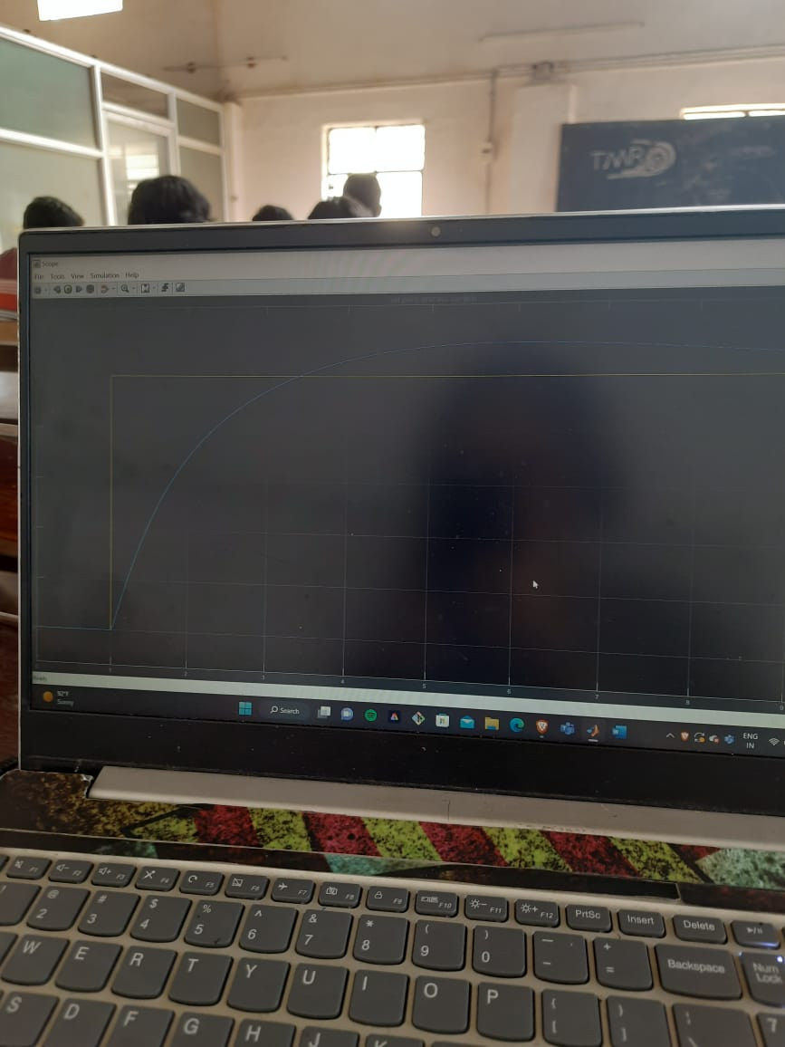

Increasing P decreased the offshoot and I made the process variable meet the desired output faster.

Step4:

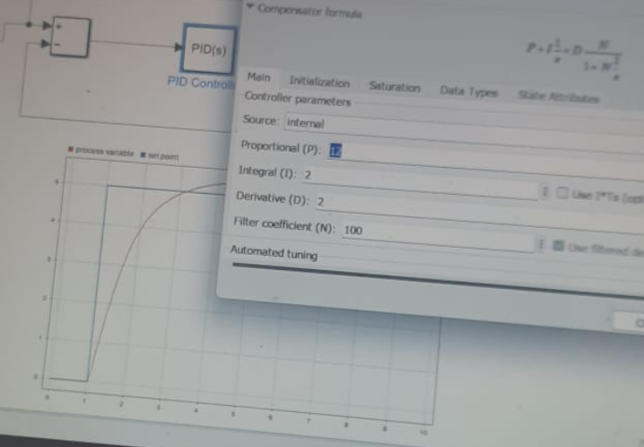

Step 5:

Step 6:

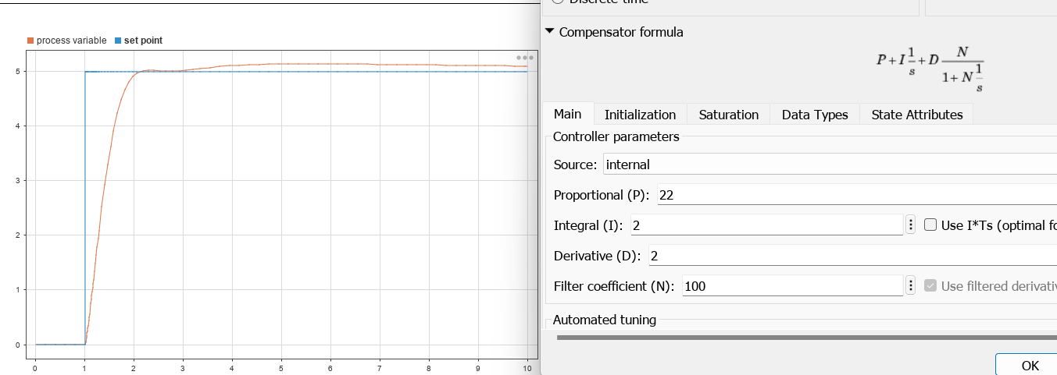

The best result got at P=22,I=2 and D=2

Because at P=24 we see an offshoot in the graph

Zieglar Nichols Method:

This method can only be used on stable processes. Open loop tests are required to estimate process characteristics.

This method can only be used with a closed loop PID controller. The aim is to push the controller to its stability limits in order to obtain estimated process characteristics.

Basically, Ziegler-Nichols works well enough when the dead time is small compared to the time constant of the process. However, small discrepancies between estimated and actual process characteristics (gain or process delay) can result in an extremely oscillatory or even unstable control loop.